Technical Project Team

VMWare Virtual Machine Migration to Hyper-V via the Datto Backup Appliance

SOP

PREPARED BY
Kelvin Aruin – Senior Technical Project Engineer

TABLE OF CONTENTS
Pre-Requisites 3
Login to the Client Datto Dashboard Page 4
Migrating the Virtual Machine to Hyper-V 7

Pre-Requisites
- The physical Hyper-V host is patched with the latest firmware
- The physical host is running a licensed version of Windows Server and has the Hyper-V role installed
- Customer VMWare virtual machines are backed up via a Datto appliance

Login to the Client Datto Dashboard Page
- Login to the Datto dashboard via https://myapps.microsoft.com or https://auth.datto.com/login
- At the login screen, select ‘Login With KaseyaOne’
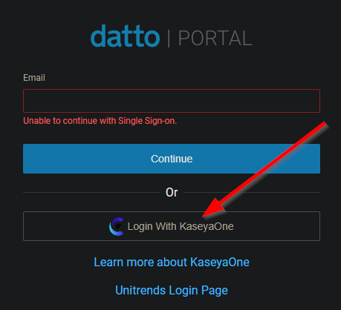
- Enter your Impact email address in the Username field and enter Impact Networking into the Company Name field:
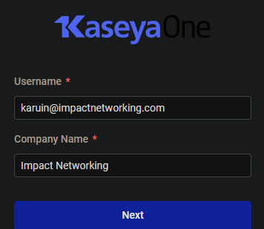
- Press ‘Next’
- On the next page, click on ‘Login with Single Sign-On’ instead of entering a password:
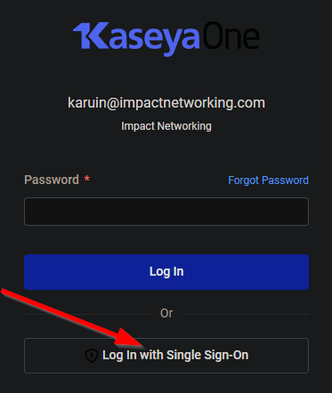
- If you entered all of the information correctly, you should now be looking at the KaseyaOne dashboard
- Click on ‘Datto BCDR Backup’ Manage:
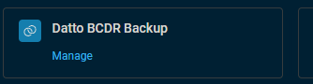
- On the ‘Backup Status’ page, under the Datto device name under the client click on the arrow under ‘Device Web’:
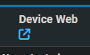
- A new tab will open
- Click Restore
- On the ‘Restore from a Backup’ page, select your server under Chose a System:
- Then select ‘Export Image’ under ‘Choose a Recovery Type’
- Then select the latest recovery point:
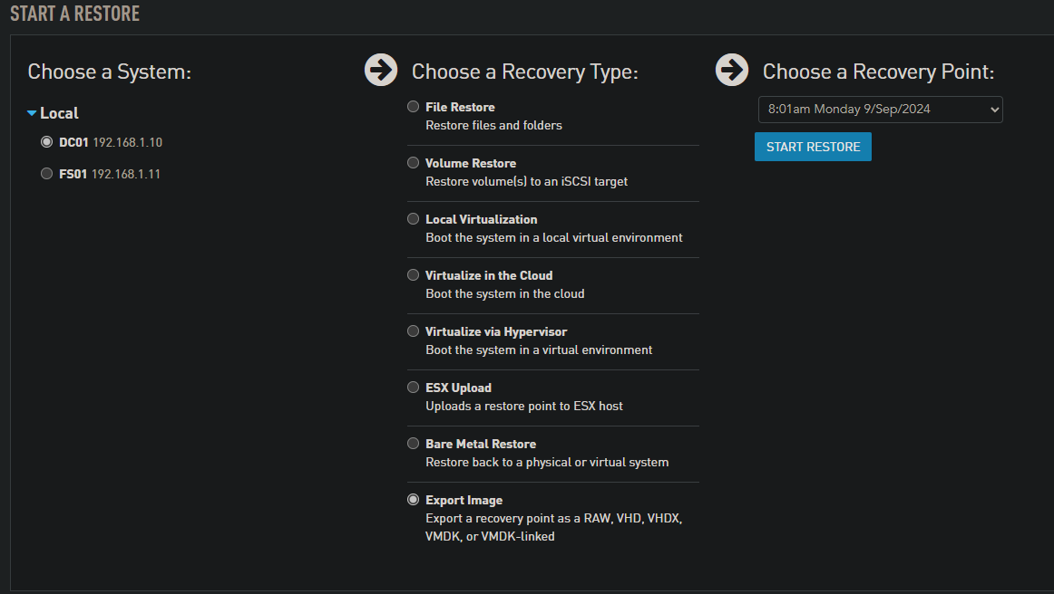
- Click ‘Start Restore’
- On the next page, leave ‘Network Share’ as the destination, change the format to ‘VHDX’, and select ‘UEFI’ under boot type:
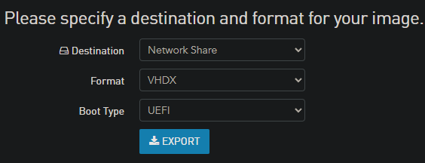
- Click ‘Export’
- You will now see a list of Mounted Restore Options

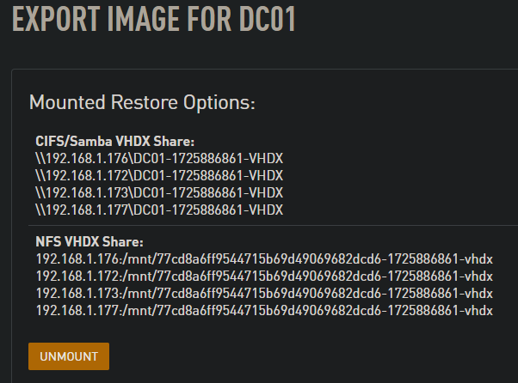
- Copy the first path under CIFS/Samba VHDX Share
- On the Hyper-V host, map a new drive and paste the path into the folder field

- Make sure to check the ‘Connect using different credentials’ checkbox
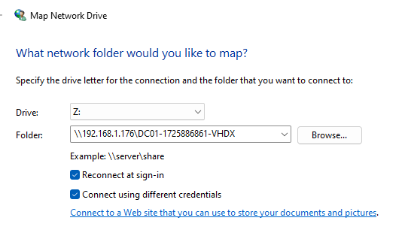
- When the credentials box pops up, enter the DattoAdmin credentials from IT Glue.
- Make sure to select ‘remember credentials’ and press the ‘OK’ button:
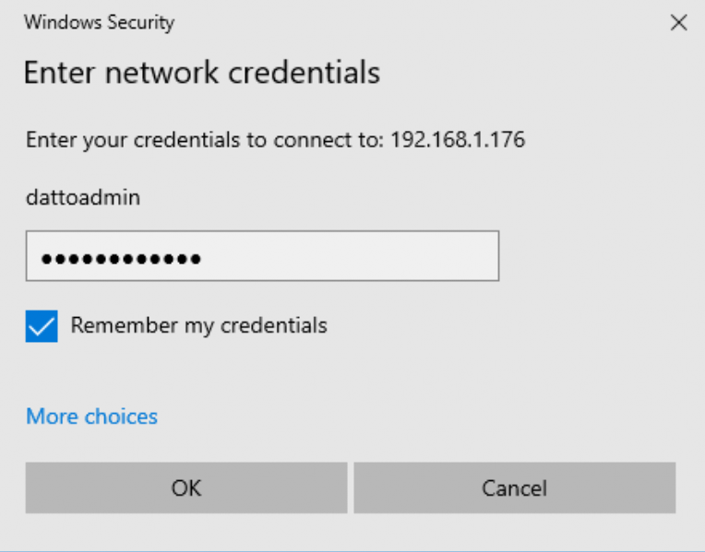

- You can now browse to the mapped drive and copy the disks to the Hyper-V virtual machine disk directory of your choice via Windows Explorer:
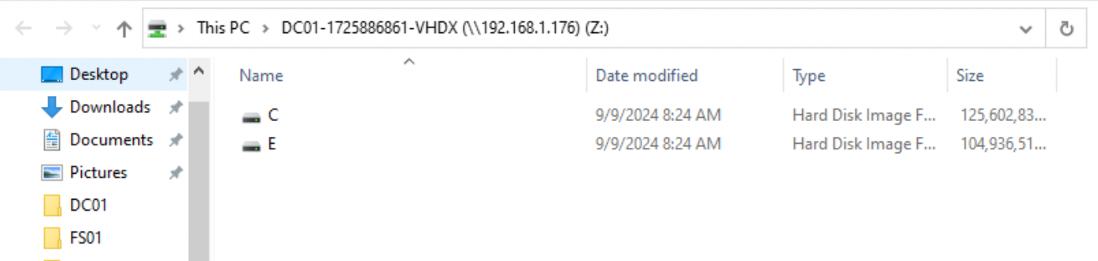
- Once you are done with the restore, make sure to go back to the Datto webpage and press ‘Unmount’ on the Export Image page:


Migrating the Virtual Machine to Hyper-V
- Once the VHDX disk(s) for your migration has been downloaded to the Hyper-V server, you will need to open the Hyper-V Manager console. You can do this by opening ‘Server Manager’ and selecting ‘Hyper-V Manager’ from the menu:
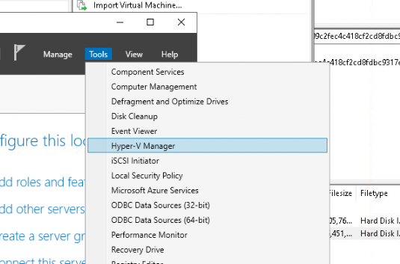

- Right-click on the server’s name and select New, then Virtual Machine…
- Skip the ‘Before You Begin’ page by pressing ‘Next’
- Name your virtual machine on the next screen and press ‘Next’
- Create a Generation 2 virtual machine with CPU and RAM settings matching the VMWare virtual machine you are migrating.
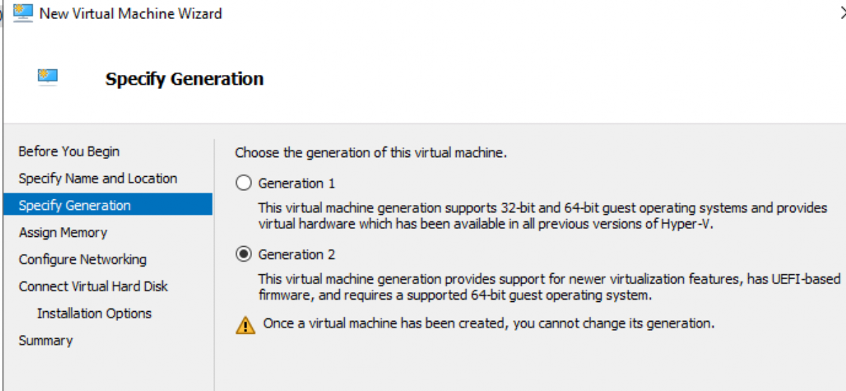
- Enter the amount of RAM in megabytes and press ‘Next’
- Select the network vSwitch on the next page and press ‘Next’
- Select “Attach a virtual hard disk later” and press ‘Next’
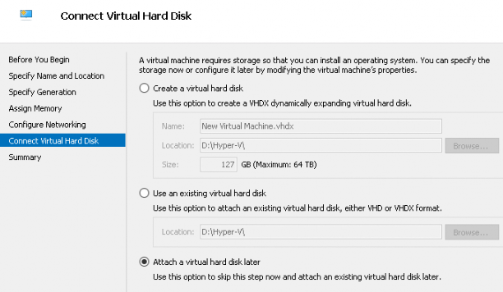
- Verify your settings on the last page, and press ‘Finish’
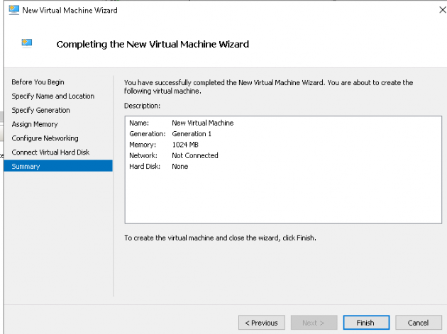
- To attach the VHDX disks you exported from the Datto appliance, locate the virtual machine in the virtual machine list in Hyper-V Manager, right-click, and select ‘Settings’
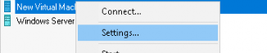
- Select SCSI Controller on the left and press the ‘Add’ Hard Drive button on the right:
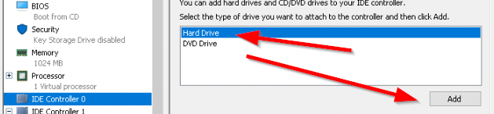
- To add your C drive, click the ‘Browse’ button and navigate to the location of your exported VHDX disk(s) via windows explorer, then press ‘Open’
- Repeat the above step for any additional hard disks and press the ‘Ok’ button to save the changes
- Right-click on the virtual machine name and select settings again
- Select the ‘Firmware’ section and make sure to move the C drive to the top in the startup order:
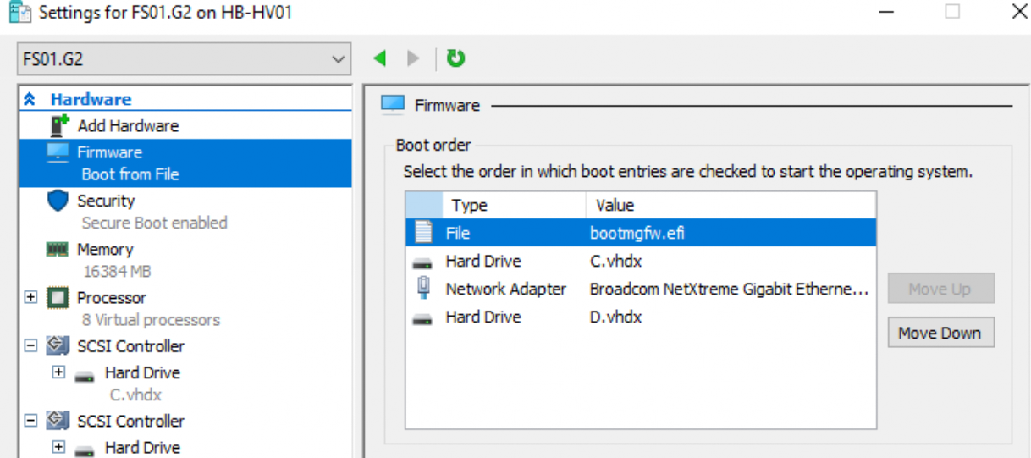
Note: Once the machine boots and restarts, the EFI file will be added as shown in the screenshot above.
- If you followed all the above instructions, you should be able to start your newly migrated server via the Hyper-V console and the migration will be complete

